Simulation-Driven Design of a PLC-Controlled 2-DOF Robotic Manipulator
Nov 6, 2026 · @klm
Mithunvel K L (Reg. No. 23BMH1029)¹, Vaishnav V G (Reg. No. 24BMH1035)¹, Nadraj¹
¹ B.Tech. Mechatronics and Automation, Vellore Institute of Technology, Chennai, India

Abstract
This paper presents the structural simulation and control design of a PLC-controlled, two-degree-of-freedom (2-DOF) pick-and-place manipulator with a 420 mm reach and a 5 kg electromagnetic payload. Static and transient finite element analyses in Ansys 2023 R1 show a maximum deflection of 0.085 mm and a minimum factor of safety (FOS) of 4.6, at the shoulder joint while holding the payload after a 90° base rotation. The simulation's load case and motion profile were then used to size the actuators: an integrated harmonic-drive servo (M8025, 101:1) at the base and a smaller one (M8010, 81:1) at the shoulder. Both are commanded in pulse/direction mode by a Kinco K615S-16DT PLC, with operator control through a Kinco M2070HE 7-inch HMI over Ethernet. The results show that the aluminium–steel structure is stiff and strong enough for the task, and that the selected drive and control hardware covers the required torque, speed and I/O with margin.
Keywords: 2-DOF manipulator, finite element analysis, transient structural analysis, factor of safety, actuator sizing, harmonic drive, PLC, HMI, pick-and-place

1. Introduction
Small pick-and-place arms are common in training labs and light industry, but they are often built by trial and error: a frame is fabricated, motors are bought from a catalogue, and problems show up only on the bench. This project takes the opposite route. The structure was checked by simulation first, and those results then fixed what the motors and controller had to deliver.
The manipulator lifts a 5 kg ferrous part with an electromagnet, swings it 90° about a vertical axis, and places it. It has two actuated joints: a base (waist) rotation and a shoulder pitch. Control uses industrial-grade parts, a PLC and a touch-panel HMI, so the arm behaves like a real automation cell rather than a hobby build.
Objectives
- Check that the arm deflects and stresses within safe limits when holding a 5 kg payload, both stationary and in motion.
- Find the most loaded component and its minimum factor of safety.
- Use the simulated loads and motion profile to select the base and shoulder actuators.
- Select a controller and operator interface that can drive both actuators, handle safety I/O, and switch the electromagnet.
Scope. This paper covers the structural simulation, actuator selection and control hardware. The PLC ladder program and HMI screens are described in Section 6 and will be detailed once finalised.

2. System overview
The arm is a two-axis manipulator: a base that rotates about the vertical axis, and an upper arm (Link-1) that pitches at the shoulder. A short drop link (Link-2) at the end of Link-1 carries the electromagnet. Each actuated axis has its own integrated servo, so the system has exactly two degrees of freedom.
Subsystem | Component | Material / model
Base | Fixed housing with base motor | Mild steel AISI 1010
Joint (shoulder) | Shoulder motor, bearing housing, pin shaft | Mild steel AISI 1010
Link-1 | Two side plates, cross member, end pin | Aluminium 6061
Link-2 + end effector | Drop link and electromagnet | Aluminium 6061
Base actuator | Integrated harmonic-drive servo | M8025(B)E25B101L
Shoulder actuator | Integrated harmonic-drive servo | M8010(B)E17B81L
Controller | Compact PLC, 8 DI / 8 DO | Kinco K615S-16DT
Operator panel | 7-inch touch HMI, Ethernet | Kinco M2070HE
Workspace. The reference point P is at the Link-2 axis. It reaches R = 420 mm from the shoulder. In plan view it sweeps a ring of Ø843 mm around the base, and the shoulder covers a 180° arc in the vertical plane (Figure 1).
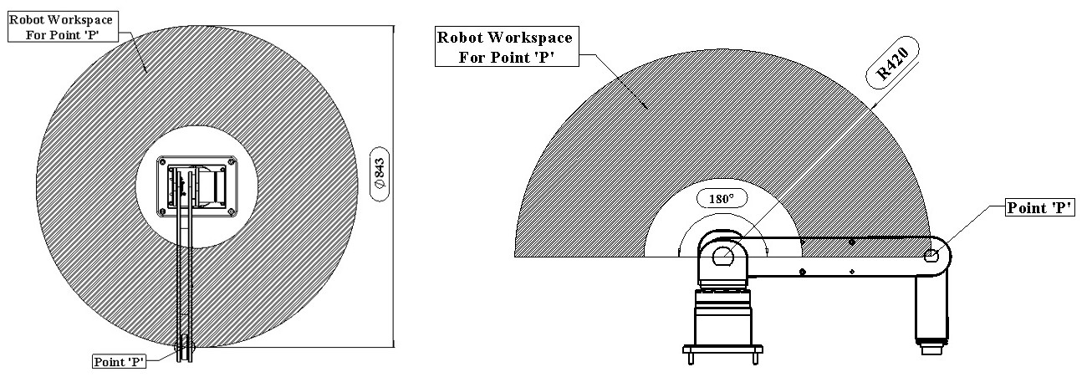
Figure 1: Robot work envelope for point P, plan view (Ø843 mm) and side view (R420 mm, 180° shoulder arc).
Task cycle. The arm picks a 5 kg part at the origin, rotates 90° about the base, lowers and places it, and returns. This cycle is the load case used in the transient simulation (Section 3.5).

3. Simulation methodology
All analyses were run in Ansys Mechanical 2023 R1. A static structural analysis covers two held poses, and a transient structural analysis covers a full 120 s pick-and-place cycle.

3.1 Geometry preparation
The full CAD assembly was cleaned before meshing. Bolts, screws and bearings were removed, small features such as holes and fillets were suppressed, and idealised bonded contacts were defined between mating parts. These steps improve mesh quality and cut solve time without significantly changing the global stiffness (Figure 2).
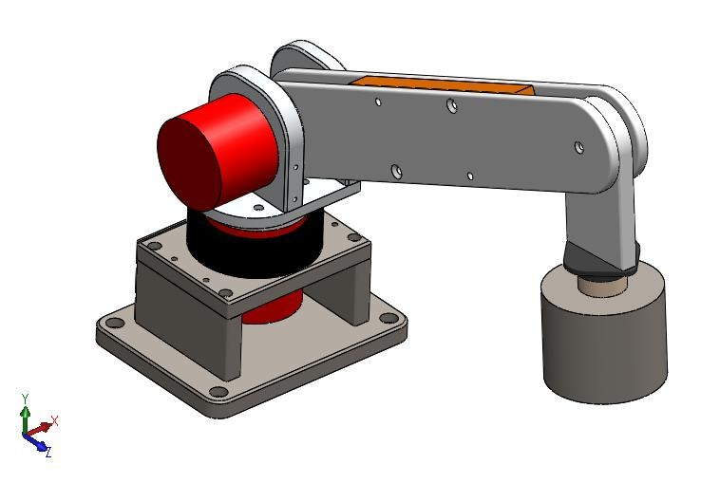
Figure 2: Robotic arm after CAD clean-up, showing the base, base motor, joint motor, Link-1, Link-2 and 5 kg load.
The cleaned assembly was then grouped into five bodies, each treated as one continuous solid (Figure 3):
- Base: housing integrated with the base motor body.
- Joint: shoulder motor, bearing housing and pin shaft. Its rotation is defined about the global Y axis.
- Link-1: Arm-1, Arm-2, cross member and the bearing-holding pin shaft.
- Link-2 + end effector: drop link and electromagnet.
- Payload: a 5 kg steel cylinder representing the part.
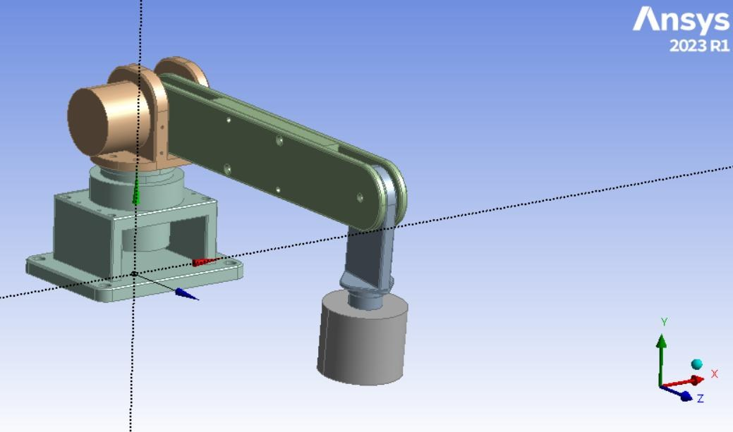
Figure 3: Simulation model with five bodies.

3.2 Materials
Stationary, heavily loaded parts use structural steel. The moving links use aluminium 6061 to reduce the inertia and gravity torque the motors must carry.
Property | Mild steel AISI 1010 | Aluminium 6061
Used for | Base, joint, payload | Link-1, Link-2
Density (kg/m³) | 7872 | 2713
Yield strength, tensile & compressive (MPa) | 250 | 259.2
Ultimate tensile strength (MPa) | 460 | 313.1
Young's modulus (GPa) | 200 | 68.9
Bulk modulus (GPa) | 166.6 | 58
Poisson's ratio | 0.30 | 0.33
Aluminium 6061 has almost the same yield strength as the steel at about one third of the density. Its stiffness is also about one third, so the links are expected to show the largest deflections.

3.3 Meshing
All bodies were meshed with a uniform 5 mm element size (Figure 4). This resolves the link plates and joint housing through their thickness while keeping the model small enough for a time-stepped transient solve. A formal mesh convergence study was not part of this work (see Section 7).
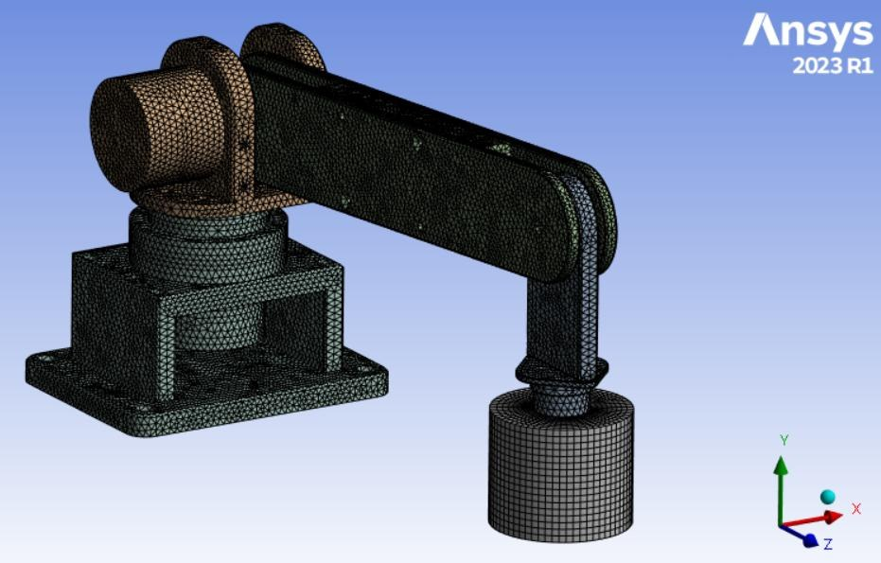
Figure 4: Body mesh with 5 mm element size.

3.4 Static structural set-up
- Support: base body fixed in all degrees of freedom.
- Gravity: standard earth gravity, 9.81 m/s² in −Y, acting on every body.
- Payload: the self-weight of the 5 kg load at the end effector, about 49 N.
Two poses were solved:
- Pose A, pick-up: arm extended over the origin, part just gripped.
- Pose B, holding: base rotated 90°, Link-1 raised, part held (Ansys label "Up – Rotate 90_Deg").
The outputs were total deformation, equivalent (von Mises) stress, and the safety factor:
\mathrm{FOS} = \frac{\sigma_y}{\sigma_{vM,\max}}
Here σy is the material yield strength and σvM,max is the peak von Mises stress in the body. Ansys caps the displayed FOS at 15.

3.5 Transient structural set-up
The transient analysis applies time-dependent rotational displacements to the joints, with the base fixed, gravity on, and the 5 kg payload attached during the pick phase.
Joint | Prescribed rotation
Base motor shaft (joint body, about Y) | 0° to 90° and back
Link-1 (shoulder pitch) | 0° to 25° and back
Link-2 (end-link orientation) | 0° to 15° in the text; the plotted profile peaks at 10°
The motion sequence over the 120 s cycle is:
- 0–30 s: pick at the origin and rotate 90° to the target.
- 30–60 s: raise and lower Link-1 and Link-2 to place the part.
- 60–90 s: rotate back 90° to the origin.
- 90–120 s: raise and lower again to pick and then drop the part at the origin.
Angles were ramped smoothly between points to avoid unrealistic acceleration spikes (Figure 5).
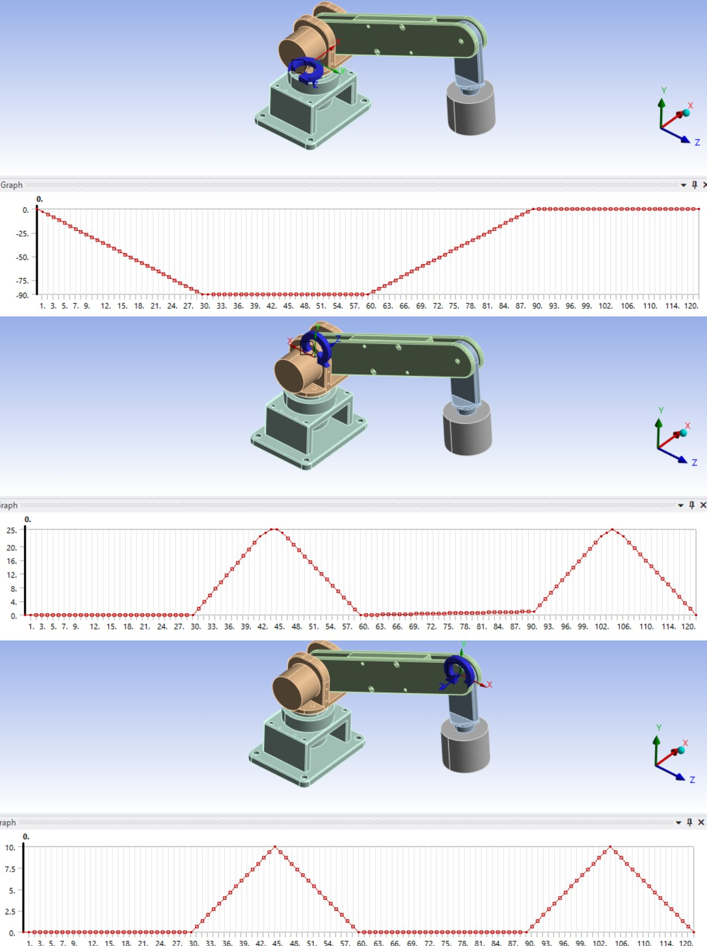
Figure 5: Prescribed rotation vs time for the joint (base), Link-1 and Link-2.
Only two motors are fitted. Link-2 has no motor of its own, so its prescribed rotation stands for the end link's change in orientation as Link-1 pitches, not a third actuated axis.

4. Simulation results
In every case the arm stays elastic and very stiff. The largest deflection is 0.085 mm, at the Link-2 tip in the pick-up pose. The lowest safety factor is 4.63, in the joint body in the holding pose.

4.1 Static analysis, Pose A (pick-up)
Deformation grows from the fixed base out to the end of the arm, as expected for a gravity-loaded cantilever (Figure 6). Stresses are low everywhere. The joint carries the highest stress, 8.81 MPa, because it reacts the full moment of Link-1, Link-2 and the payload (Figure 7).
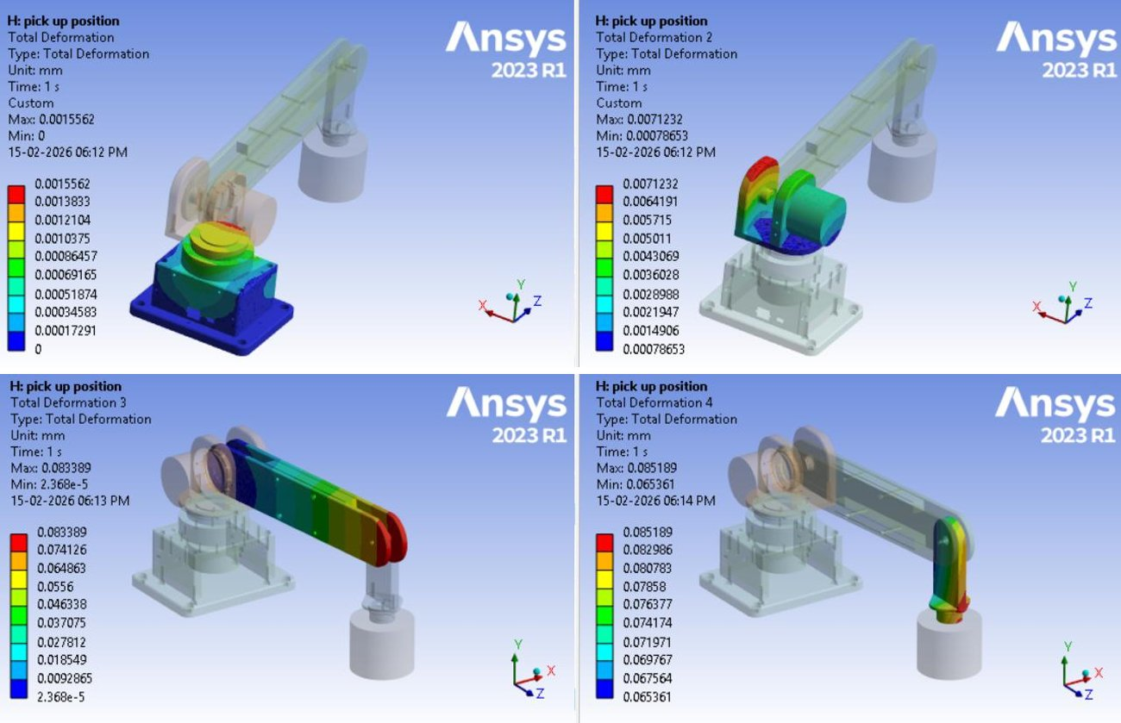
Figure 6: Total deformation of the four structural bodies at the pick-up position.
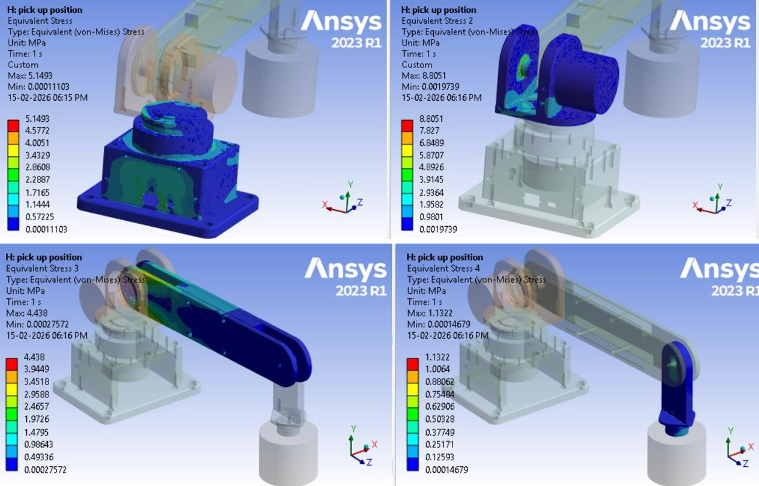
Figure 7: Equivalent (von Mises) stress in the four structural bodies at the pick-up position.
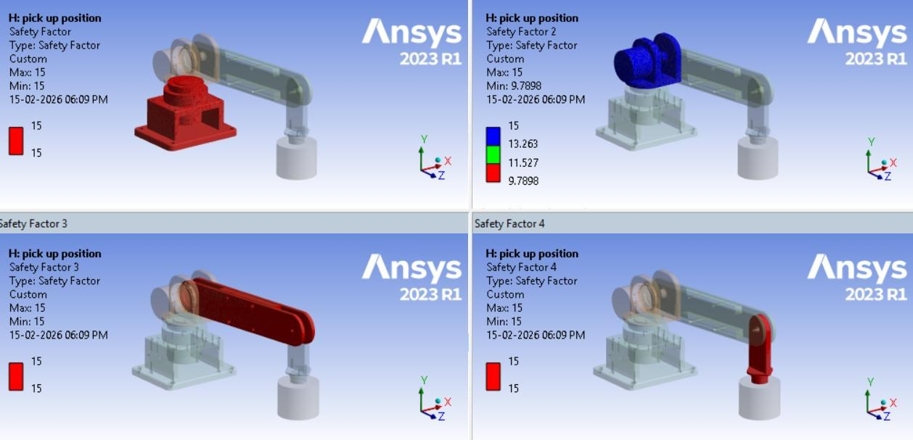
Figure 8: Factor of safety of the four structural bodies at the pick-up position.

4.2 Static analysis, Pose B (holding at 90°)
With the base turned 90° and Link-1 raised, deflections fall by about 20% because the arm's horizontal lever arm is shorter (Figure 9). The joint's FOS drops to 4.63 because the raised arm changes how the bending moment passes through the joint housing and pin (Figure 10). Link-1 also drops below the display cap, to 9.02.
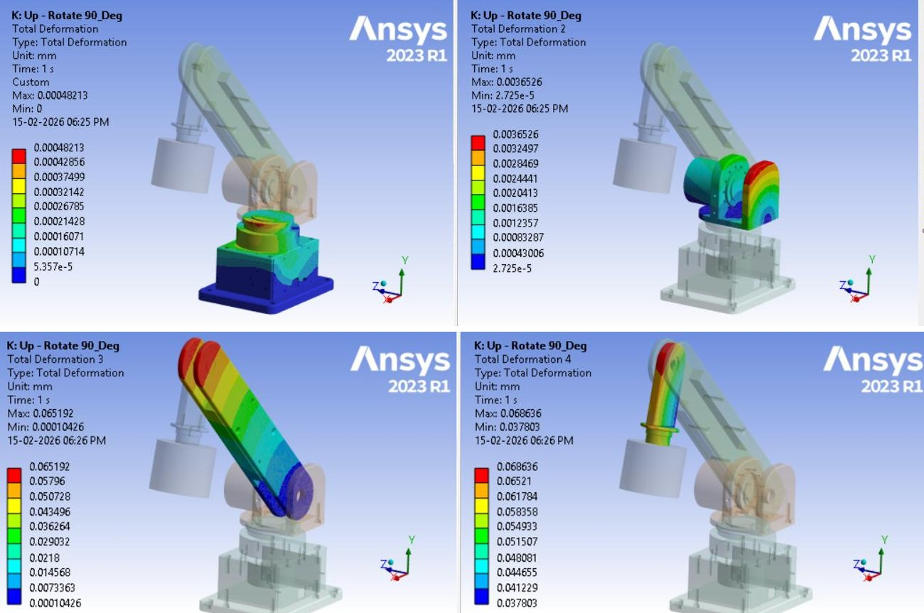
Figure 9: Total deformation of the four structural bodies at the holding position.
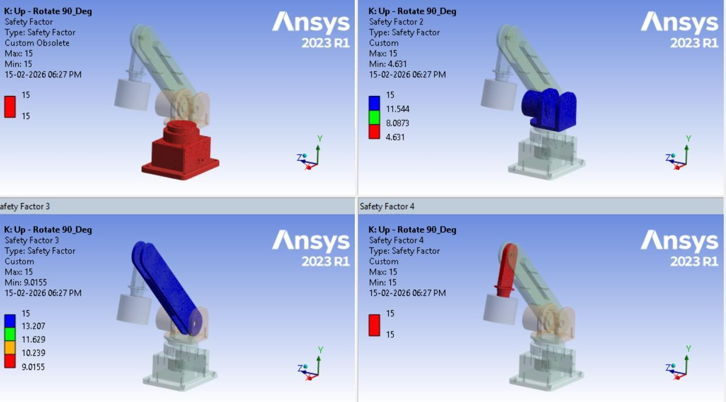
Figure 10: Factor of safety of the four structural bodies at the holding position.
Body | Max deformation, Pose A (mm) | Max deformation, Pose B (mm) | Max stress, Pose A (MPa) | Min FOS, Pose A | Min FOS, Pose B
Base | 0.0016 | 0.0005 | 5.15 | ≥15 | ≥15
Joint | 0.0071 | 0.0037 | 8.81 | 9.79 | 4.63
Link-1 | 0.0834 | 0.0652 | 4.44 | ≥15 | 9.02
Link-2 + magnet | 0.0852 | 0.0686 | 1.13 | ≥15 | ≥15
"≥15" means the result reached Ansys's display cap of 15. Stress plots were produced for Pose A only.

4.3 Transient analysis
The motion over the 120 s cycle is slow: 90° in 30 s at the base is a mean speed of 3°/s (0.5 rpm). Inertial loads are therefore small, and the dynamic response stays close to the static case (Figure 11).
Body | Max deformation at t = 120 s (mm) | FOS
Base | 0.0058 | ≥15
Joint | 0.0012 | ≥15
Link-1 | 0.071 | ≥15
Link-2 + magnet | 0.0010 | ≥15
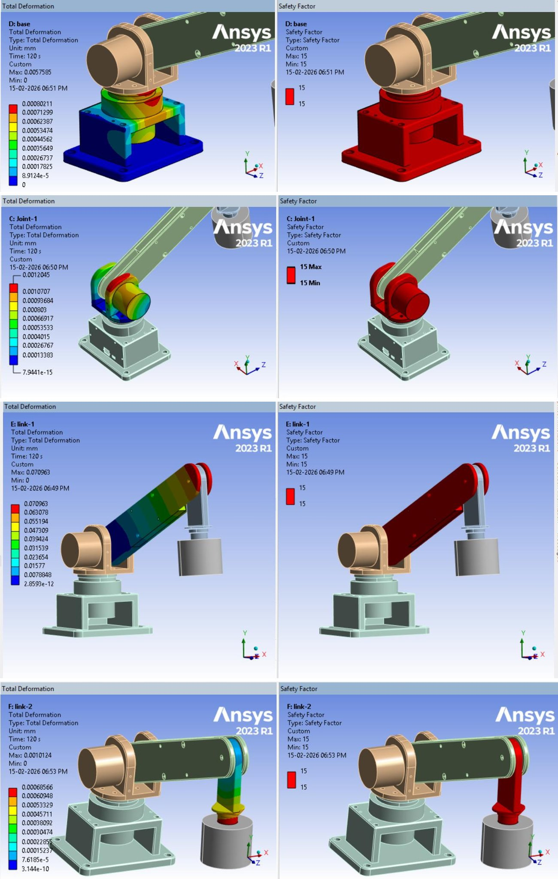
Figure 11: Total deformation and FOS of the base, joint, Link-1 and Link-2 during motion (end of cycle).
The motion did not produce a lower FOS than the static holding pose, so the governing case for design is Pose B, static holding, joint FOS = 4.63.

5. Actuator selection from the simulation
The simulation fixed three things the motors must satisfy: the gravity moment of the governing load case, the speed and acceleration of the 120 s motion profile, and a tip accuracy consistent with the 0.085 mm structural deflection. Both axes use integrated harmonic-drive servos (motor, drive, absolute encoder and strain-wave reducer in one housing).

5.1 Shoulder actuator (M8010, 81:1)
The shoulder is the gravity-loaded axis. Its worst case is Link-1 horizontal with the part held at full reach, the same geometry as static Pose A.
T_g = g\left(m_1\frac{L}{2} + (m_2 + m_p)\,L\right)

T_{req} = 1.1\,T_g + (J_{arm} + N^2 J_{rotor})\,\alpha
Quantity | Value | Basis
Reach L (shoulder to point P) | 0.42 m | Work envelope drawing
Payload m_p | 5 kg | Design requirement
Link-1 mass m_1 | 2.0 kg (assumed) | Replace with CAD mass
Link-2 + magnet mass m_2 | 1.5 kg (assumed) | Replace with CAD mass
Gravity torque T_g | 30.9 N·m | Equation above
Arm inertia about shoulder J_arm | 1.26 kg·m² | Point masses + uniform Link-1
Reflected rotor inertia N²J_rotor | 0.45 kg·m² | 0.69×10⁻⁴ kg·m² × 81²
Acceleration, simulated profile (25° in 14 s) | 0.009 rad/s² | Gives 0.02 N·m, negligible
Acceleration, fast check (25° in 2 s) | 0.44 rad/s² | Gives 0.75 N·m
Required torque T_req, with 10% friction allowance | 34.7 N·m | Fast-move case
The M8010 family is rated at about 35 N·m continuous and 56 N·m peak at the 80:1 ratio, with output speed up to 18 rpm (vendor data). The 81:1 unit fitted here is expected to match. That gives a margin of about 1.6 on peak torque. Continuous holding at full horizontal reach sits close to the rated value, so long dwell times should be spent with Link-1 raised, or with the holding brake engaged (the "(B)" option). The simulated cycle needs only about 0.5 rpm at the output, far below the speed limit.

5.2 Base actuator (M8025, 101:1)
The base turns about a vertical axis, so gravity produces no driving torque. Inertia sets the drive torque, and the bending (overturning) moment from the arm passes through its output bearing.
- Drive torque: with J about 1.3 kg·m², the simulated 90°-in-30 s move needs under 0.01 N·m. Even a fast 90°-in-3 s move needs about 0.9 N·m plus the reflected rotor inertia.
- Overturning moment: the full shoulder load, about 31 N·m plus the weight of the joint and shoulder motor, acts as a bending moment on the base output flange. This, and the governing FOS of 4.63 at the joint mounted on it, is why a larger frame was chosen than drive torque alone requires.
- Rating: the M8025 is rated at 85 N·m continuous and 178 N·m peak at 80:1 (200 W motor, 2.5 kg) (vendor data). The 101:1 version trades speed for torque, and its top speed of about 15 rpm is still 30 times the 0.5 rpm the cycle needs.

5.3 Why harmonic-drive integrated servos
Criterion | Requirement from the simulation | What the actuator gives
Backlash | Small next to the 0.085 mm tip deflection | Under 20 arcsec, which is 0.04 mm at a 420 mm reach
Resolution | Repeatable pick at the same point | 15-bit encoder × 101:1 is about 0.8 µm at the tip (base axis)
Holding | Hold 5 kg at 90° (governing case) without drift | Closed-loop servo + optional brake
Homing | Know the arm position at power-up | Multi-turn absolute encoder + zero output (ZO)
Wiring | Compact panel, few cables | Drive built in: pulse/direction + CAN on one connector
Speed | Pulse rate within the PLC's limits | About 8 kHz at 10,000 pulses/rev for the cycle speed, against 200 kHz available
The combined error budget at the tip is the 0.085 mm structural deflection plus the 0.04 mm gear backlash, about 0.13 mm in total. That is well within what an electromagnetic gripper tolerates.
Open check: the vendor rates both modules at 36 VDC ±10%, but the wiring drawing feeds them from the 24 V supply. At 24 V, top speed falls roughly in proportion. That is acceptable here, but the motor labels should be checked to confirm the supply rating.

6. Control architecture
A Kinco K615S-16DT PLC drives both servos in pulse/direction mode, reads their alarm and zero signals, switches the electromagnet through a relay, and handles the emergency stop. A Kinco M2070HE HMI gives the operator jog, auto-cycle and status screens over Ethernet.

6.1 Why a PLC
A microcontroller board could generate step pulses, but the arm was designed to behave like an industrial cell. The PLC was chosen for:
- Deterministic, safe I/O: 24 VDC isolated inputs and PNP outputs, wired directly to the e-stop, buzzer and magnet relay, with no level shifting.
- Built-in motion: 3 high-speed pulse outputs at 200 kHz (plus one at 10 kHz), with PTO/PWM motion instructions and wizards in KincoBuilder. The arm needs two channels at about 8 kHz.
- Fieldbus headroom: the CAN port is a CANopen master for up to 64 slaves. The servos also speak CANopen (the repository includes their EDS file), so the arm can move from pulse control to bus control without new hardware.
- Industry-standard programming: IEC 61131-3 ladder (LD) and instruction list (IL) in KincoBuilder V8.5 or later.
- Single-vendor ecosystem: the PLC and HMI are both Kinco, and they communicate over Ethernet with Modbus TCP.
Item | K615S-16DT specification
Supply | 24 VDC
Digital I/O | 8 DI (sink/source), 8 DO (PNP, 24 VDC)
High-speed outputs | 3 × 200 kHz + 1 × 10 kHz, PTO/PWM
High-speed inputs | 3 × 200 kHz counters
Communication | 1 × Ethernet 10/100 (Modbus TCP), 2 × RS485, 1 × CAN (CANopen master)
Program memory | 8k instructions, 20 kB V+M data
Expansion | Up to 16 K6S modules

6.2 Why this HMI
The M2070HE is a 7-inch, 1024×600 touch panel with an ARM Cortex-A7 CPU, IP65 front, 10.8–28 VDC supply (4.2 W at 24 V) and an Ethernet port. It runs on the same 24 V rail as the PLC, mounts in a 192 × 138 mm cut-out, and is programmed in KincoDTools. The "E" version was chosen over the M2070H because it adds Ethernet, for both PLC communication and program download.

6.3 System architecture and I/O
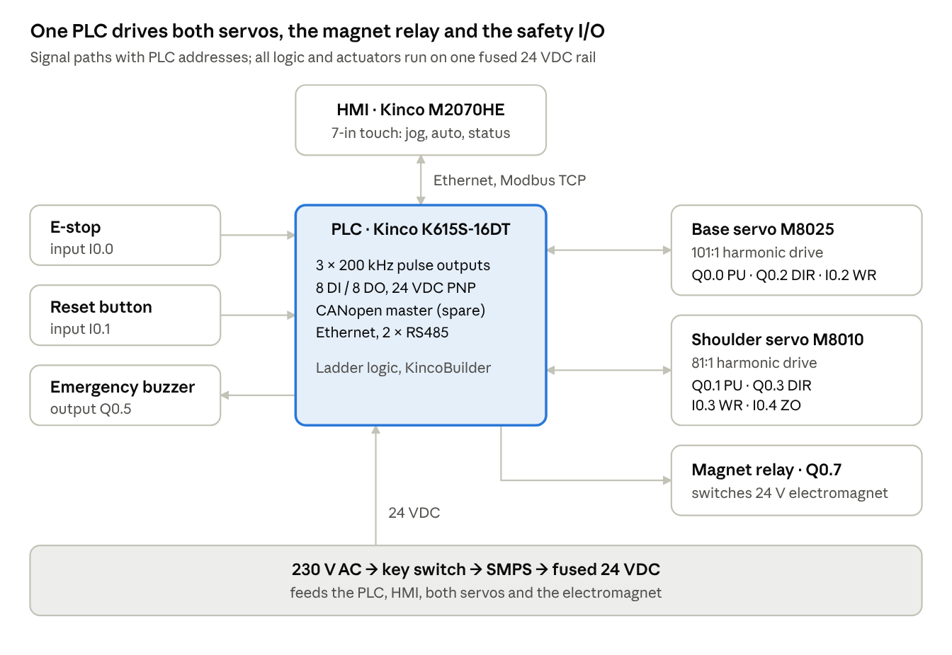
Control and power architecture · PLC, HMI, two servos, magnet relay
Figure 12: Control and power architecture.
PLC address | Signal | Connected to
Q0.0 | Base pulse (B PU+) | Base servo pulse input
Q0.1 | Shoulder pulse (S PU+) | Shoulder servo pulse input
Q0.2 | Base direction (B DIR+) | Base servo direction input
Q0.3 | Shoulder direction (S DIR+) | Shoulder servo direction input
Q0.4 | Reset output | Servo alarm reset
Q0.5 | Emergency buzzer | Buzzer
Q0.6 | Spare | —
Q0.7 | Electromagnet relay | Relay coil for the 24 V magnet
I0.0 | Emergency stop | E-stop push button
I0.1 | Reset input | Reset push button
I0.2 | Base alarm (B WR+) | Base servo alarm output
I0.3 | Shoulder alarm (S WR+) | Shoulder servo alarm output
I0.4 | Shoulder zero (S ZO) | Shoulder servo multi-turn zero output
I0.5–I0.7 | Spare | —
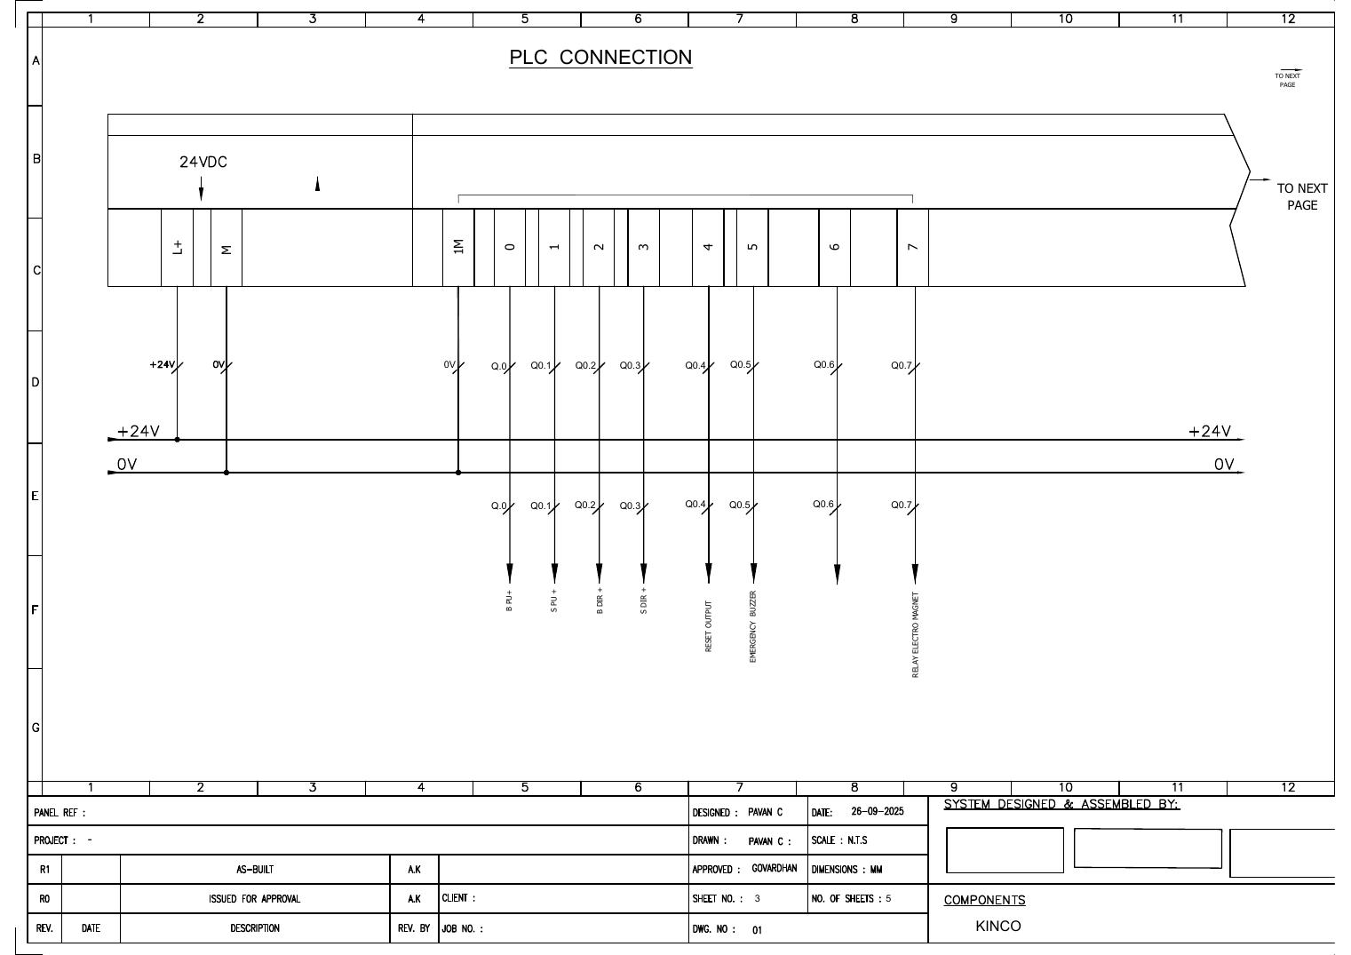
Figure 13: PLC output wiring (sheet 3 of the electrical drawing).
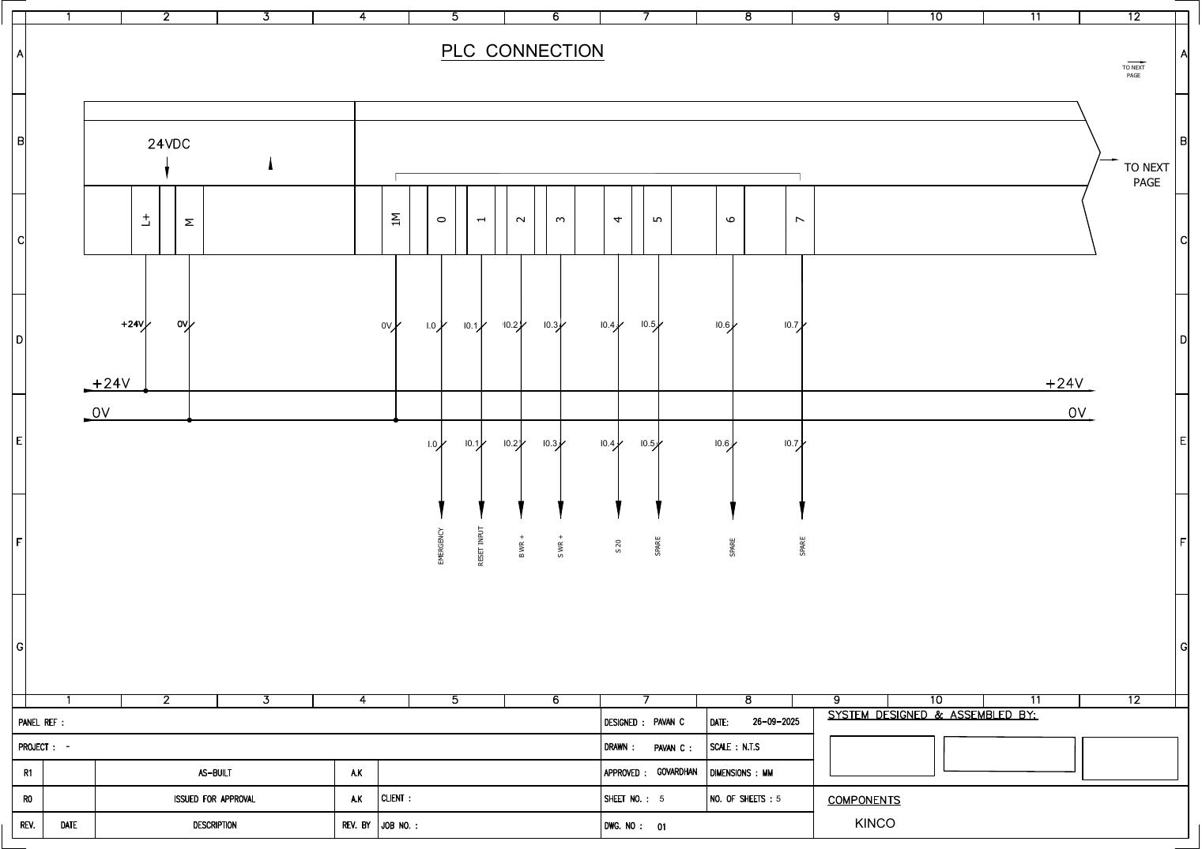
Figure 14: PLC input wiring (sheet 5 of the electrical drawing).
Power. A 3-phase + N, 440/230 V, 50 Hz supply enters through a 3-pole rotary isolator. A 230 V AC feed, switched by a key switch and push button, powers an SMPS that supplies 24 VDC through fuses to the PLC, the HMI and both servos. A 24-pin signal connector carries the pulse, direction, alarm, zero and CAN lines, and an 8-pin power connector carries 24 V/0 V to the base motor, shoulder motor and electromagnet.

6.4 PLC program
To be added: ladder logic for homing, jog, the auto pick-and-place sequence, e-stop and alarm handling.

6.5 HMI screens
To be added: screen list, tag map, and operator workflow.

7. Discussion and limitations
The structure is lightly loaded: peak stresses are under 9 MPa against yields of 250–259 MPa. The real constraint on the design is the shoulder motor torque, not the metal. Using aluminium for the links, which was justified by the simulation, keeps the gravity torque within one M8010 frame size.
The joint is the governing component because it carries the whole cantilever moment and sits on the base actuator. Its FOS of 4.63 is above the 1.5–3 range typically used for static machine parts. A target FOS should still be stated explicitly in the design requirements.
Limitations
- Removed hardware: bolts, bearings and pins were not modelled. Local stresses in these parts, often where joints fail, need a separate hand or sub-model check.
- No mesh study: a 5 mm global size was used without a convergence study. A local refinement around the joint pin bore would confirm the 4.63 value.
- Joint FOS mismatch: at Pose A the joint's peak stress of 8.81 MPa implies an FOS of about 28 (capped at 15), but the plot reports 9.79. The FOS and stress plots may come from different solves, so they should be re-run together.
- End-of-cycle results only: transient results are reported at t = 120 s. Peak values during the swings should be extracted from the full time history.
- Assumed link masses: the actuator sizing used assumed values for m₁ and m₂. Exact masses from CAD, and the joint reaction moment probed in Ansys, should replace them.
- Link-2 profile: the text gives a 15° rotation, but the plotted profile peaks at 10°. One of them should be corrected.
- Motor supply voltage: the motors are rated at 36 V but fed from 24 V (Section 5.3).

8. Conclusion and future work
Static and transient FEA show that the 2-DOF arm carries a 5 kg payload at 420 mm reach with a maximum deflection of 0.085 mm and a minimum factor of safety of 4.63, at the joint in the 90° holding pose. The simulated load case and motion profile were used to select an M8010 (81:1) harmonic-drive servo for the shoulder, with about 1.6× peak-torque margin, and an M8025 (101:1) for the base, sized for the arm's overturning moment. A Kinco K615S-16DT PLC and M2070HE HMI give two 200 kHz pulse channels, 24 V safety I/O and Ethernet operator control, with CANopen available for future bus control.
Future work
- Add the PLC ladder program and HMI screens (Sections 6.4–6.5).
- Re-run the FEA with a local mesh refinement at the joint and full time-history output.
- Replace assumed link masses with CAD values, and extract the joint reaction torque from Ansys to confirm motor sizing.
- Move motion control from pulse/direction to CANopen to read encoder position and current back into the PLC.
- Validate experimentally: measure tip deflection under the 5 kg load and compare it with the 0.085 mm prediction.

References
- Arcedus Technologies India Pvt. Ltd., 2DOF Robotic Arm – Simulation Technical Report, 15 Feb 2026.
- K. L. Mithunvel, PLC-2-DOF-manipulator, GitHub repository: hardware list, electrical drawings, wiring details, work envelope, servo EDS file, PLC/HMI program backup.
- Shanghai Kinco Automation, K6S Series User Manual (K6S_usermanual_V000, Dec 2023), in reference 2, docs/.
- Shanghai Kinco Automation, Kinco K Series PLC Application Manual, in reference 2, docs/.
- Kinco Automation, MASS Series HMI M2070H/M2070HE flyer, Apr 2023, in reference 2, docs/.
- M8010 harmonic gear servo joint module, vendor product page.
- M-series DC integrated servo joint module (M8025), vendor product page.
- YZ-AIM EasyCAN integrated servo user manual v3.1.20: pulse/direction, WR and ZO signal definitions.
- ANSYS Inc., Ansys Mechanical 2023 R1.

